**Localhost:**

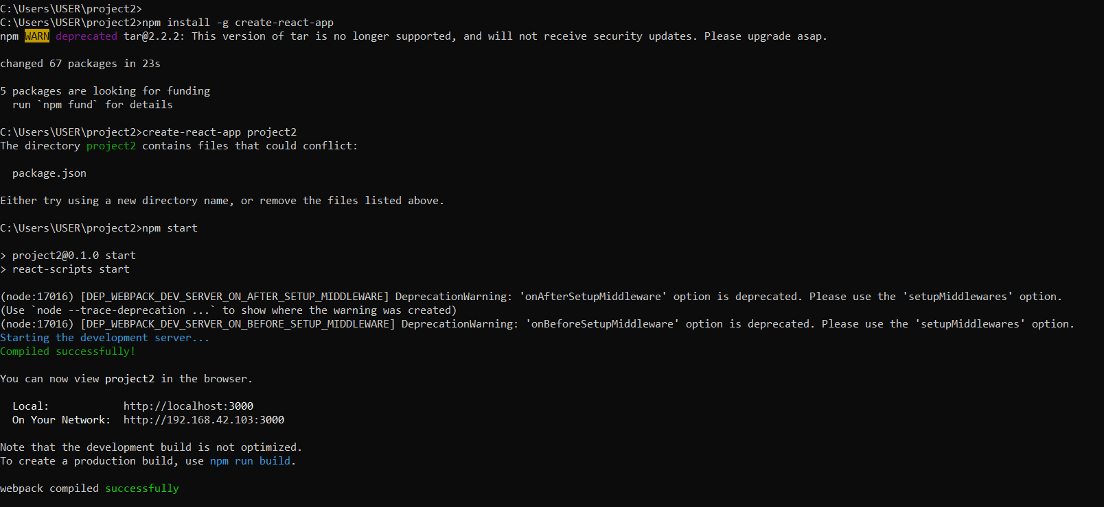

**Reactjs installation:**

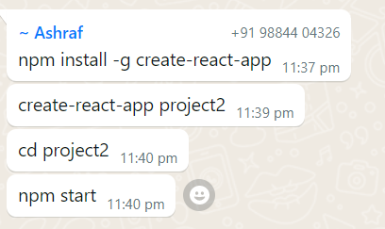

**File concept: prog 5**

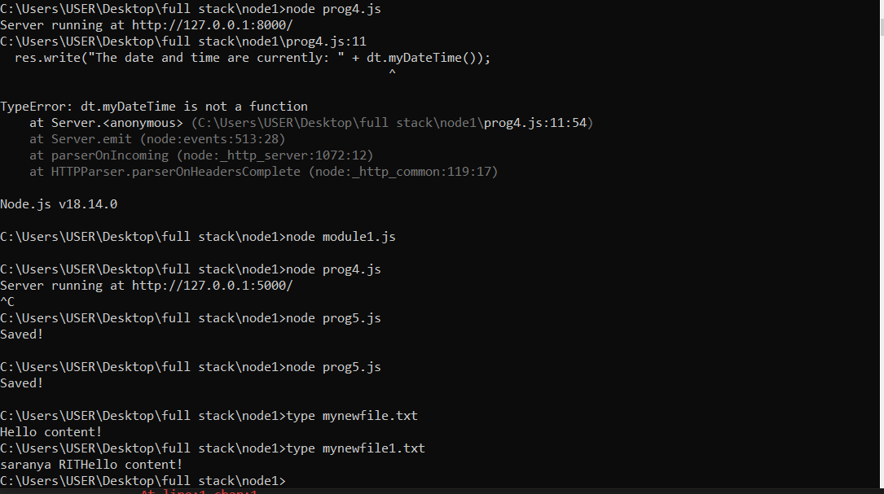

**Prog 6:**

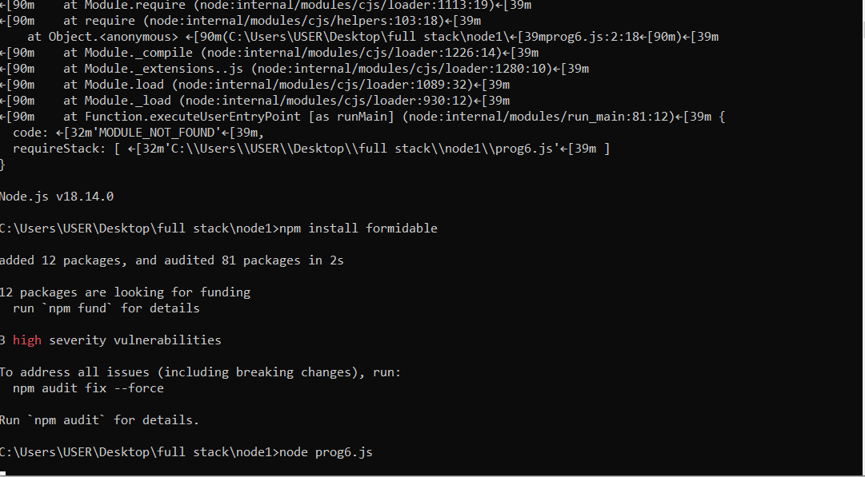

**o\p**

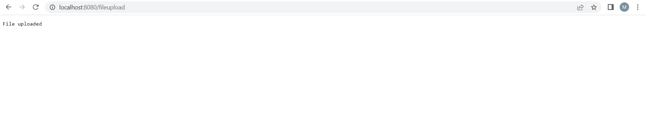

**MySQL Install**

**Link:** [**https://dev.mysql.com/downloads/file/?id=516926**](https://dev.mysql.com/downloads/file/?id=516926)

**CREATE TABLE Persons (**

**PersonID int,**

**LastName varchar(255),**

**FirstName varchar(255),**

**Address varchar(255),**

**City varchar(255));**

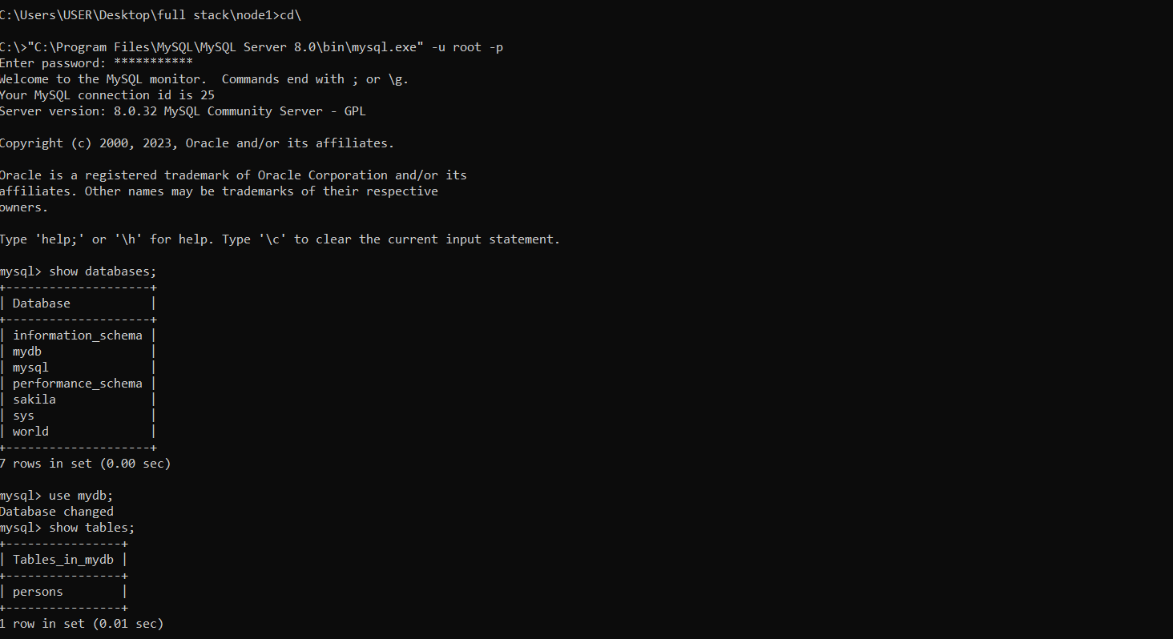

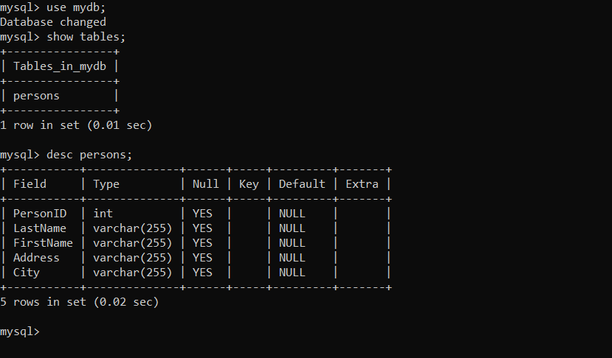

**Important site: Webflow.com**

**Vue install**

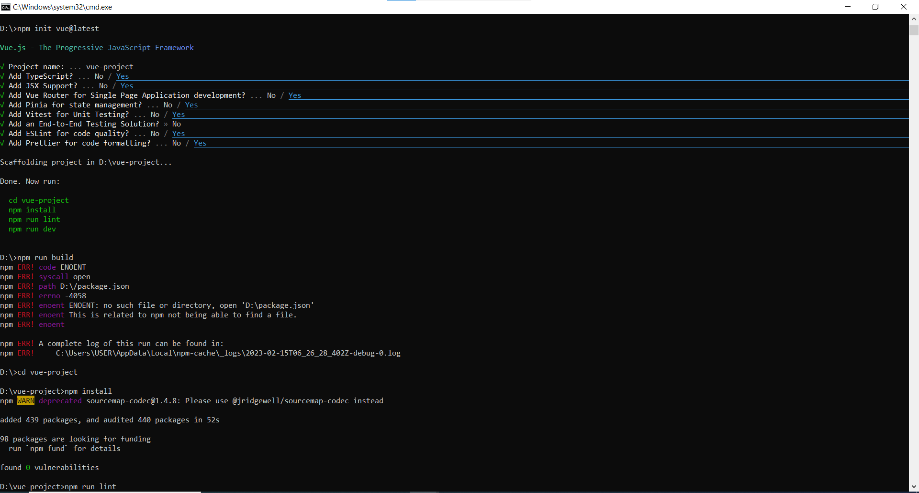

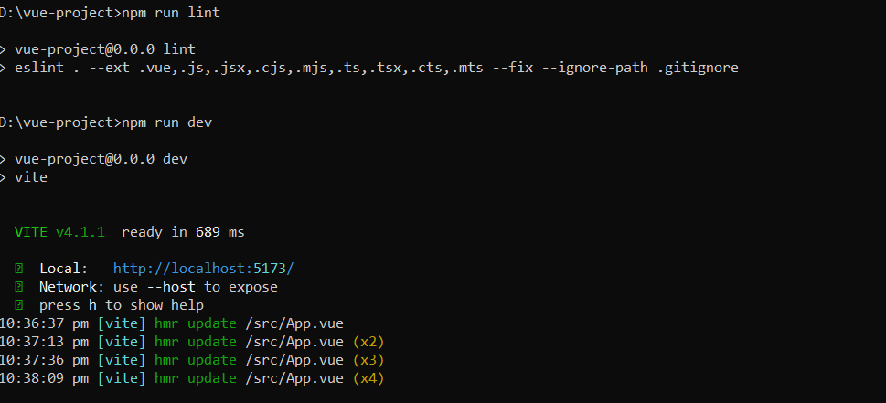

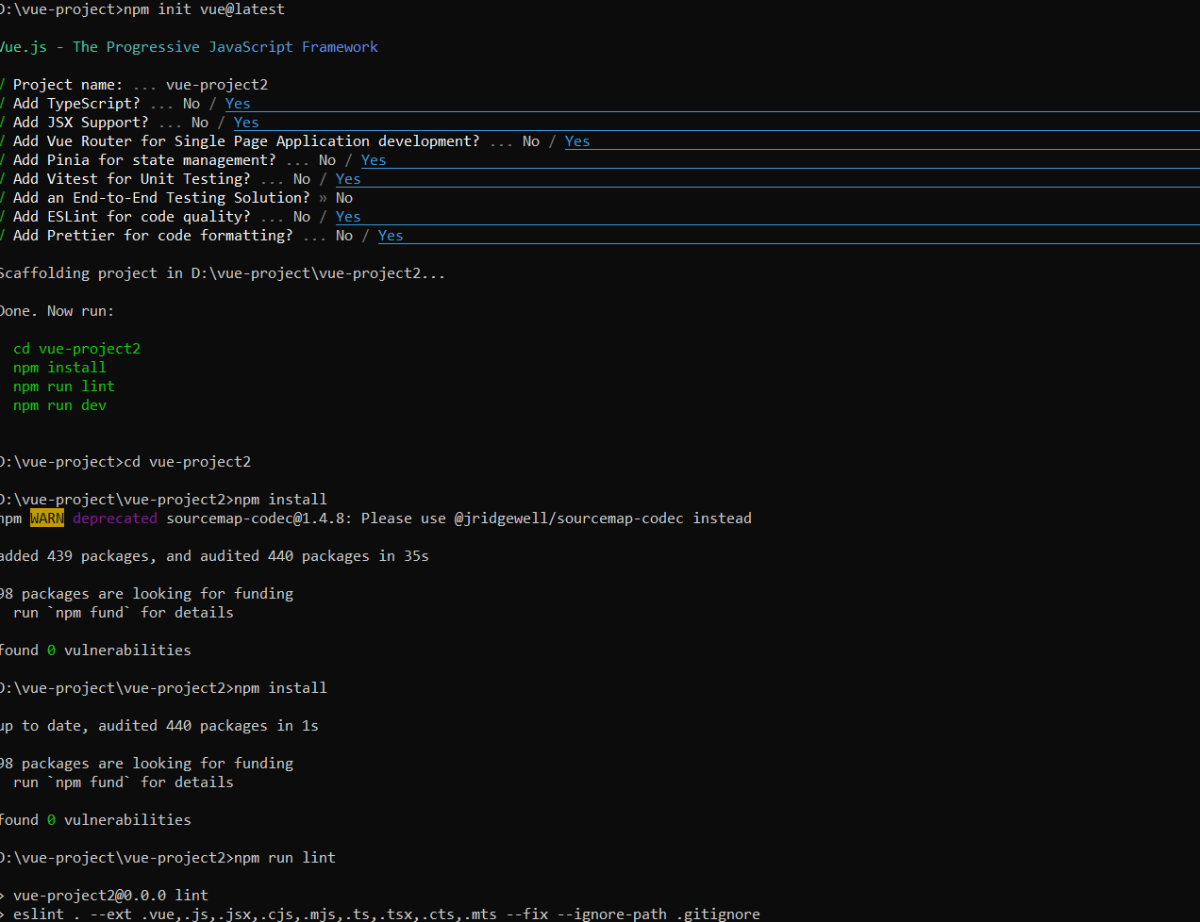

**If you want to do the first project again follow the steps in below screenshot**

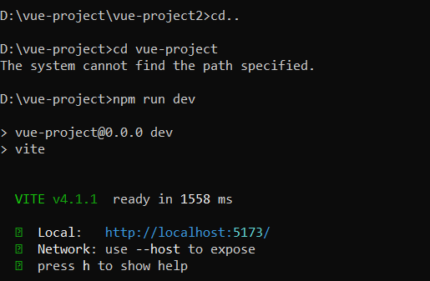

**Typrscript working**

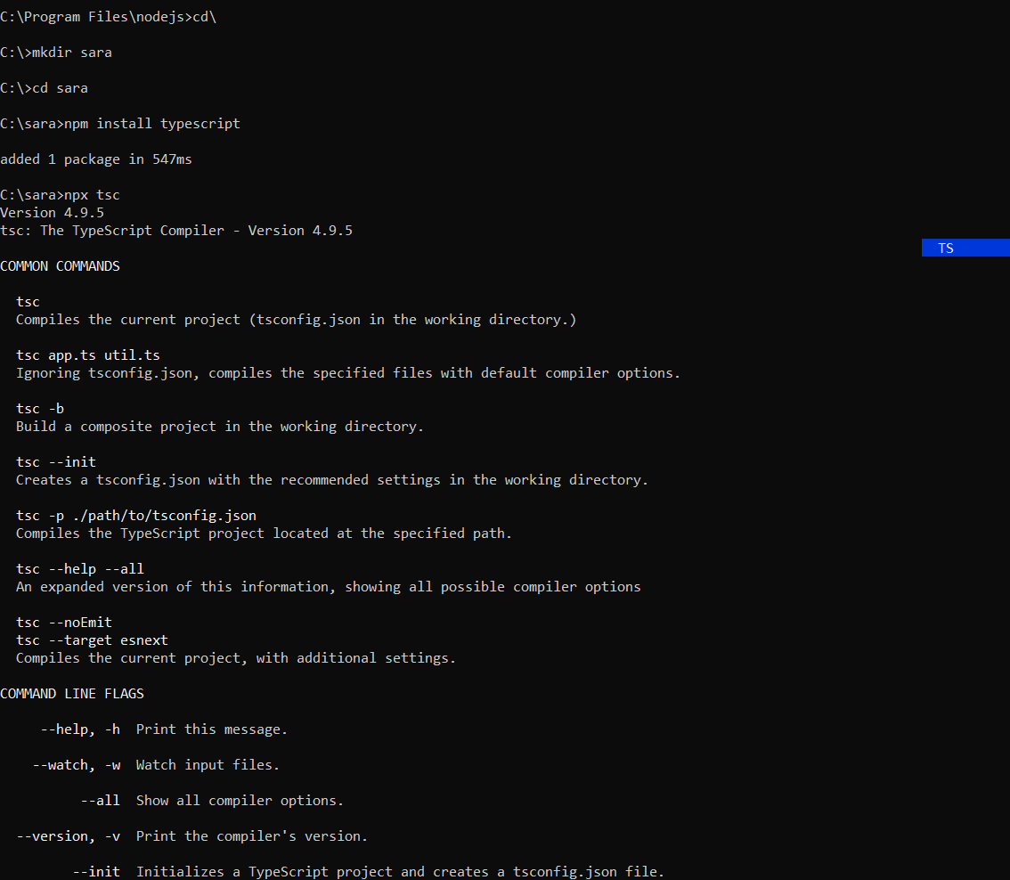

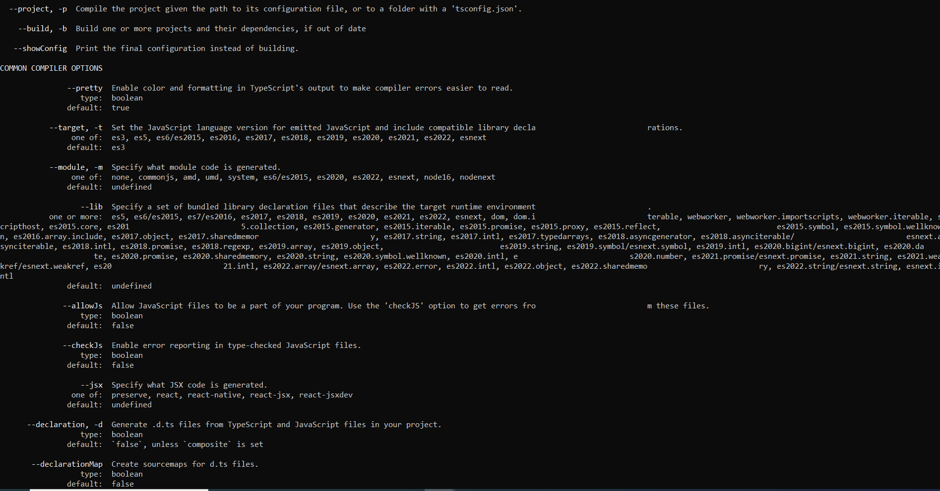

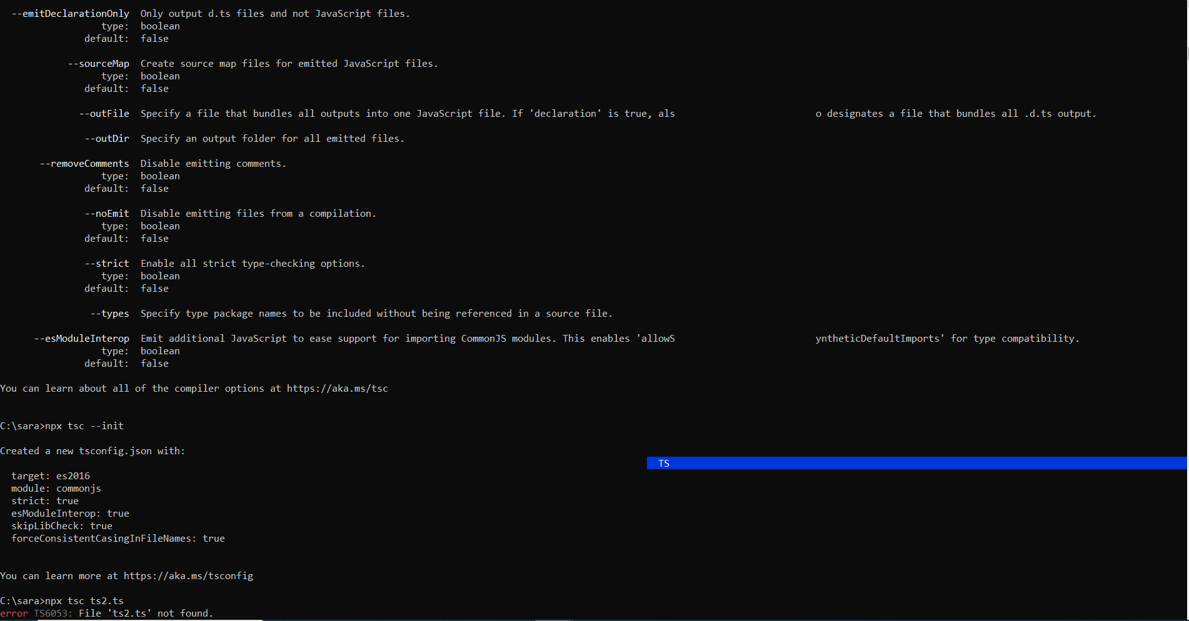

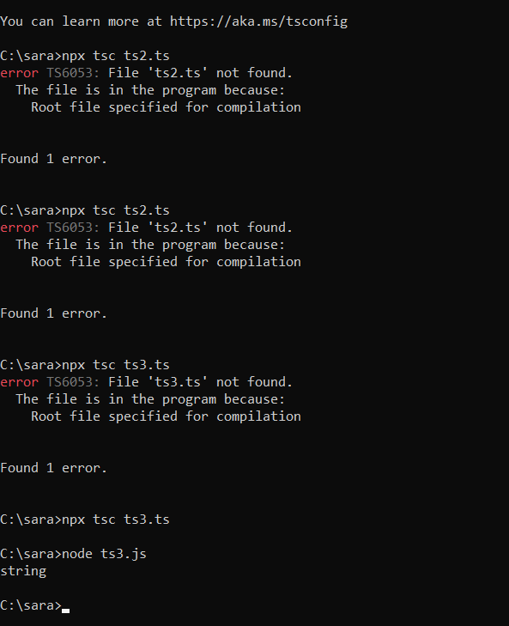

**Vue-router page:**

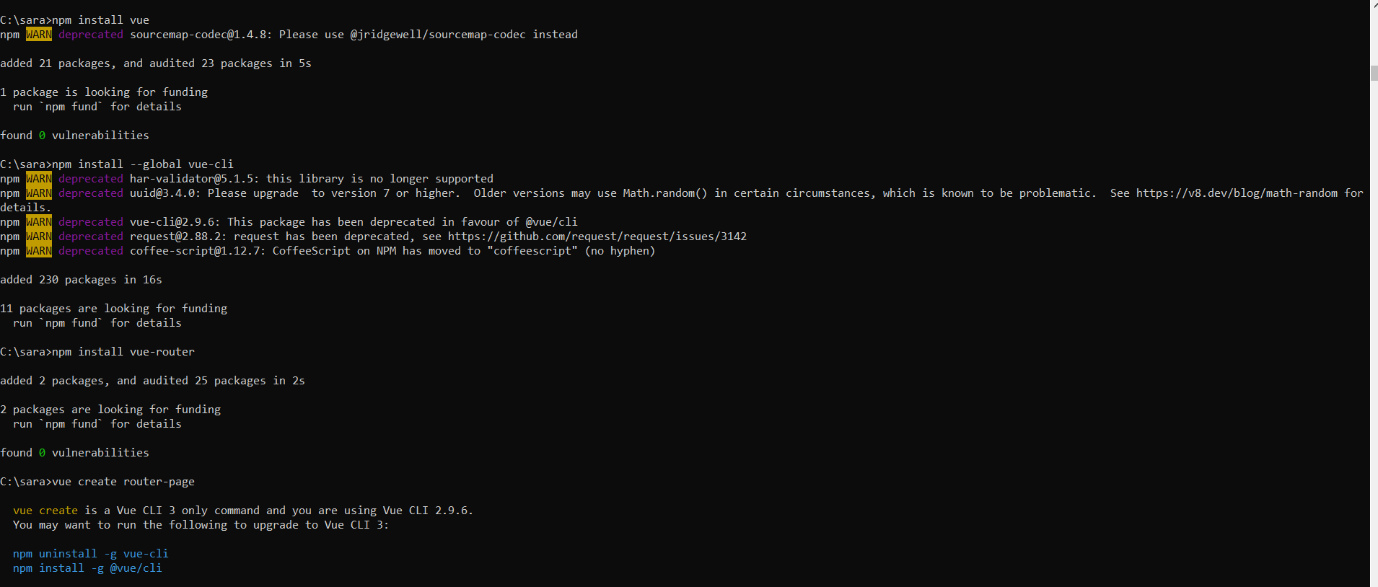

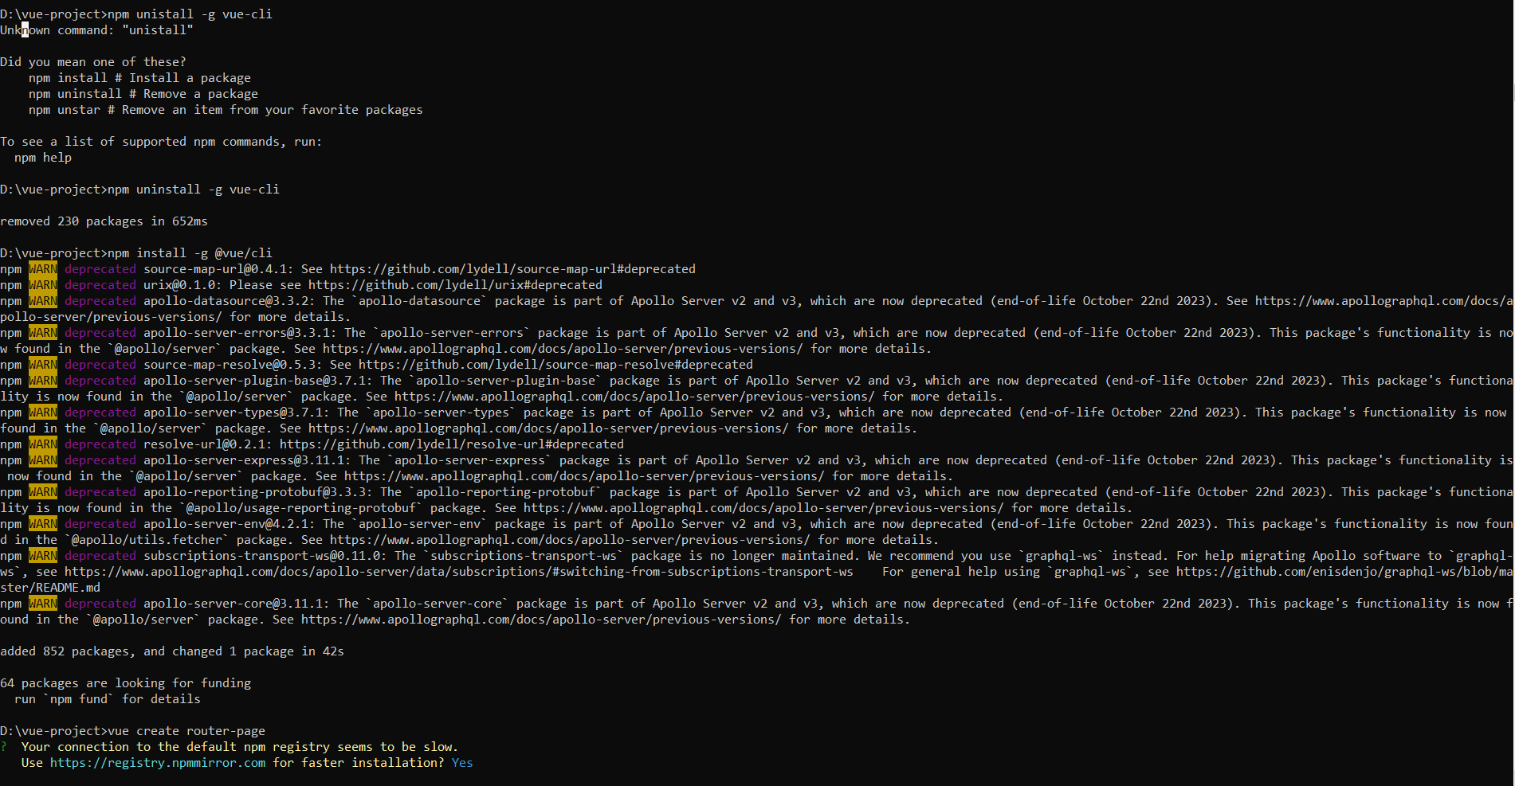

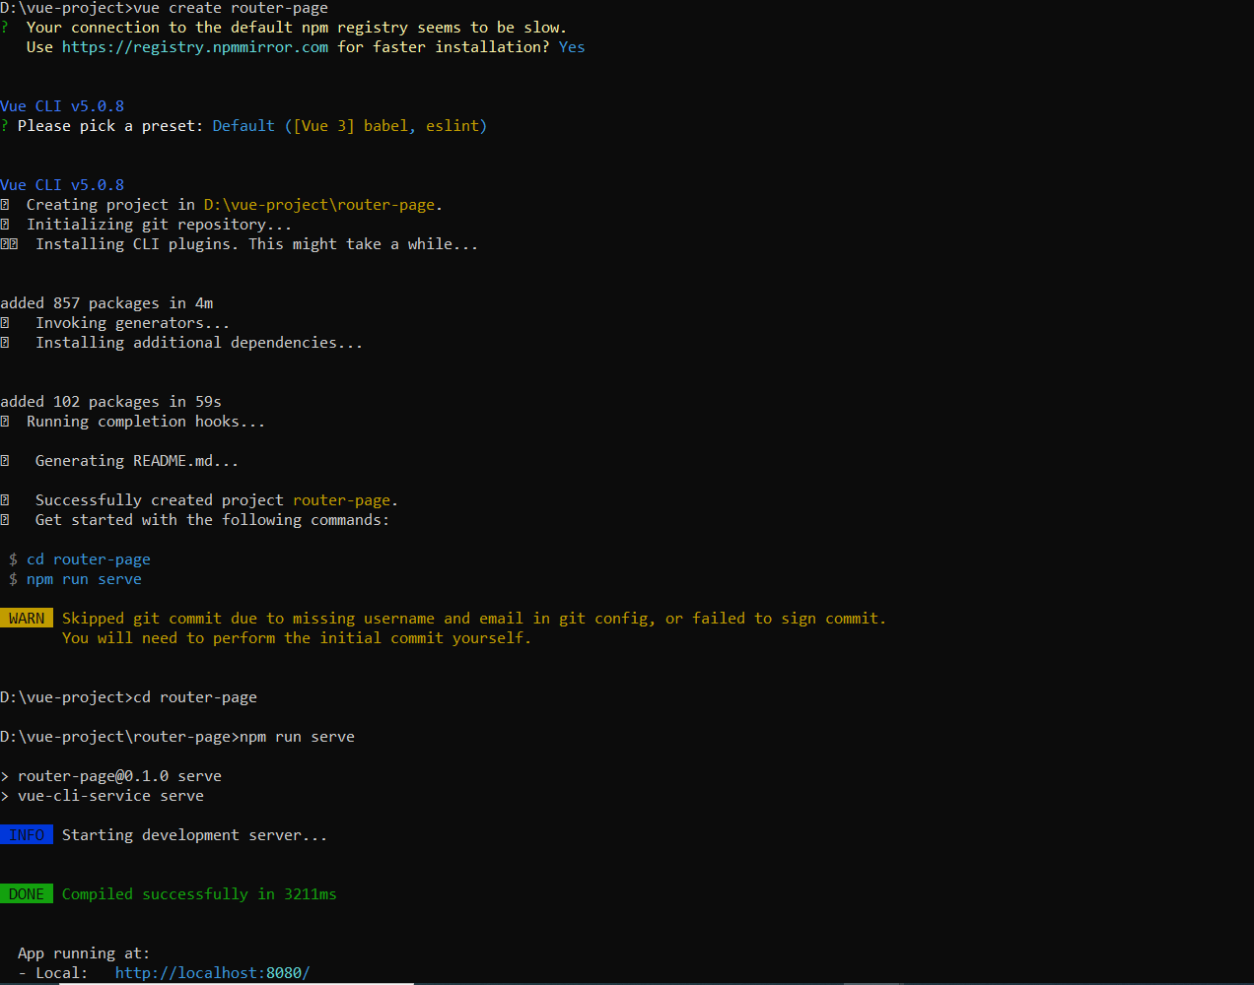

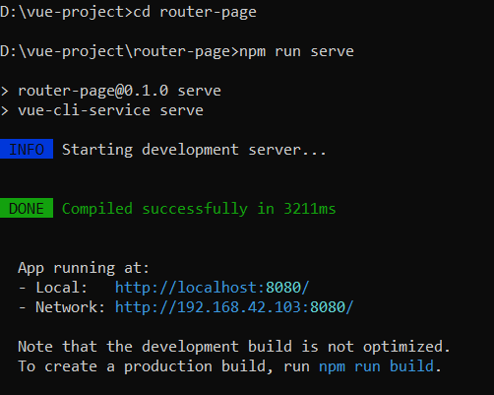

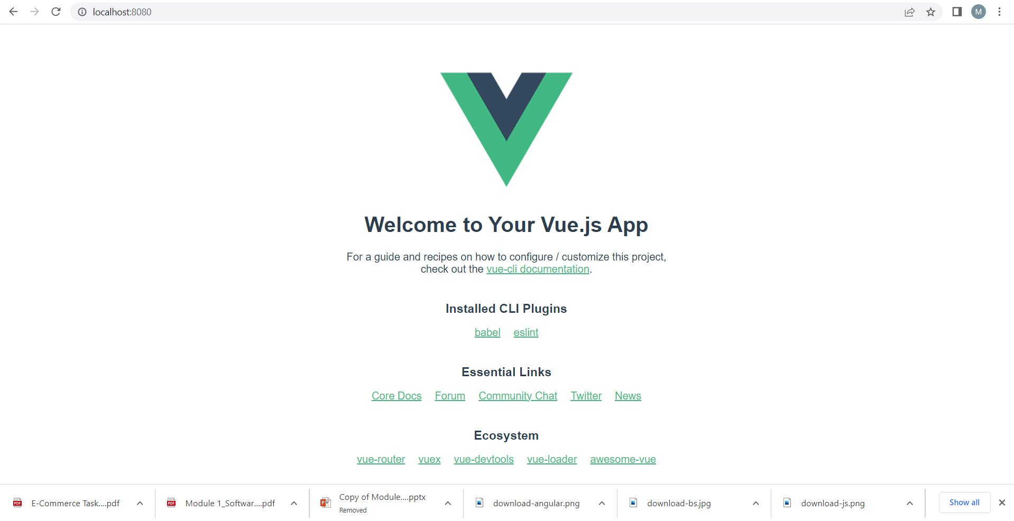

# [MongoDB connecting from Shell](https://techyjargon.blogspot.com/2023/02/mongodb-connecting-from-shell.html)

MongoDB

MongoDB can be installed locally, which will allow you to host your own MongoDB server on your hardware. This requires you to manage your server, upgrades, and any other maintenance.

You can download and use the MongoDB open source Community Server on your hardware for free.

However, for this course we are going to use MongoDB Atlas, a cloud database platform. This is much easier than hosting your own local database.

Creating a Cluster

After you have created your account, set up a free "Shared Cluster" then choose your preferred cloud provider and region.

1)Setup Atlas follow steps below.

https://www.mongodb.com/docs/atlas/mongo-shell-connection/

By default, MongoDB Atlas is completely locked down and has no external access.

You will need to set up a user and add your IP address to the list of allowed IP addresses.

Under "Database Access", create a new user and keep track of the username and password.

Next, under "Network Access", add your current IP address to allow access from your computer.

1)

Connect to Your Database Deployment,Click Connect.

Click Database in the top-left corner of Atlas.

In the Database Deployments view, click Connect for the database deployment to which you want to connect.

2)Choose your Connection Security

3)Choose how you want to limit connections to your database deployment.

Add a Connection IP Address

4)Create a Database User

5)Connect to your Atlas database deployment with mongosh

2) Install MongoDB Shell (mongosh)

mongosh --version

1) add path through control panel settings

connection string example: choose the the db name and use name correctly

mongosh "mongodb+srv://cluster0.7wmndeq.mongodb.net/myFirstDatabase" --apiVersion 1 --username ashraf1

**MongoDB -Command Prompt**

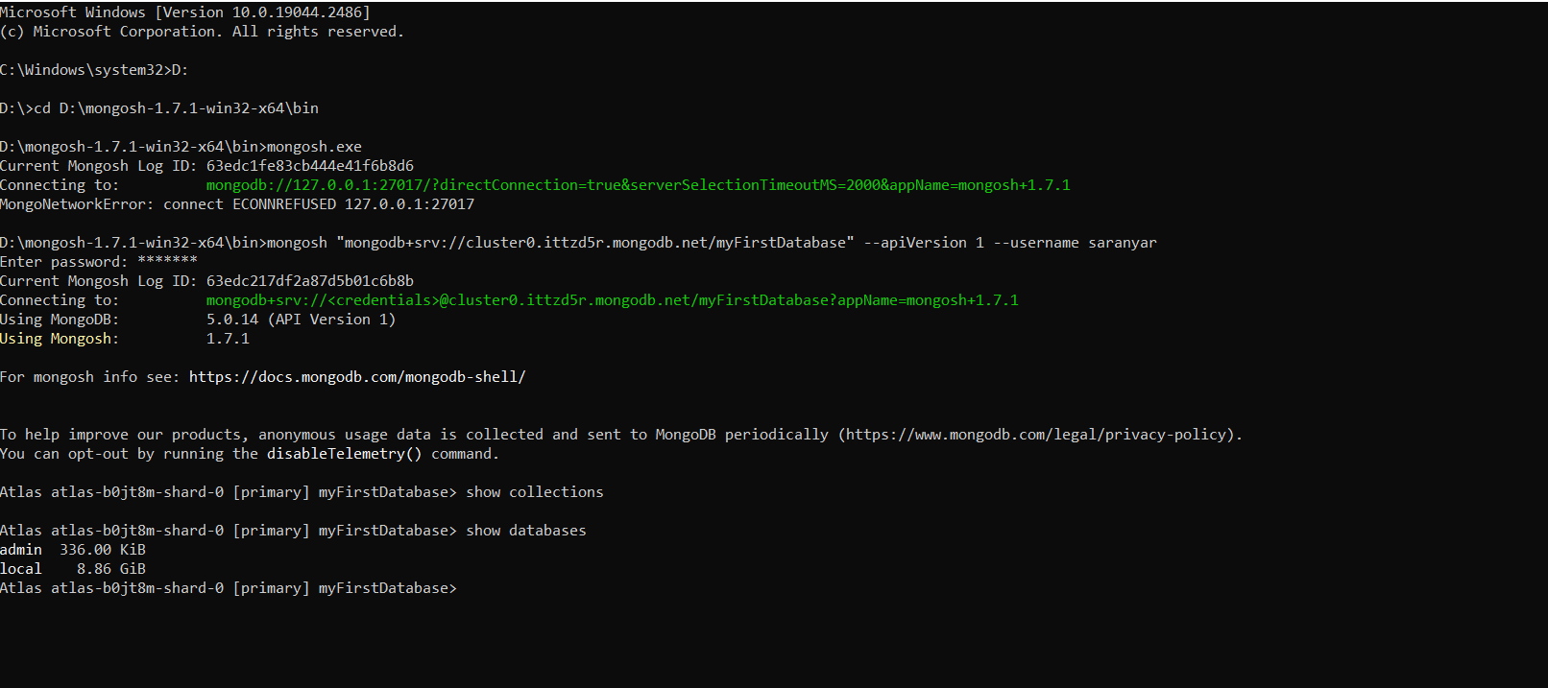

**Goto VS Code extensions and type mongoDB and install it..**

**Another one is Robo3T install and work MongoDB..**

**Express.js:**

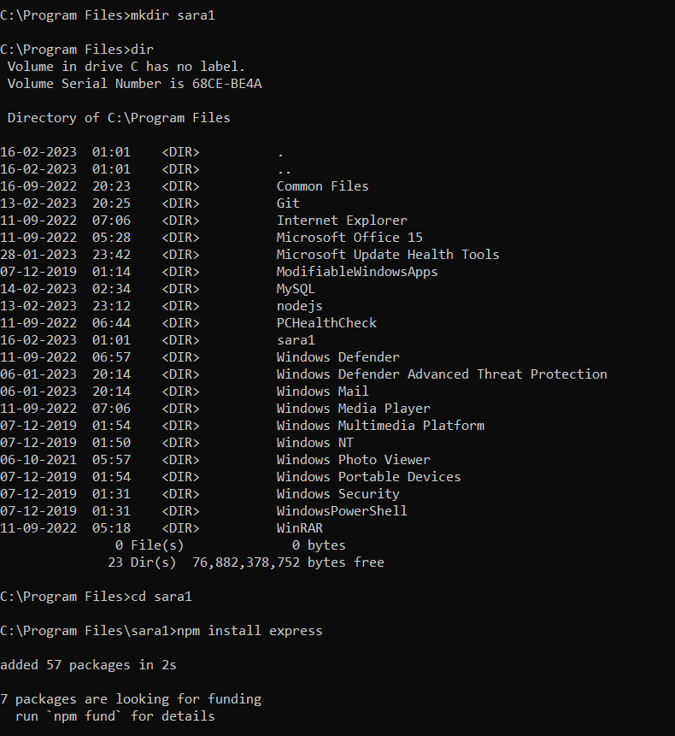

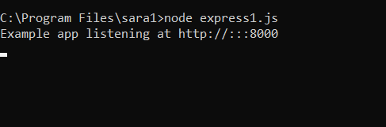

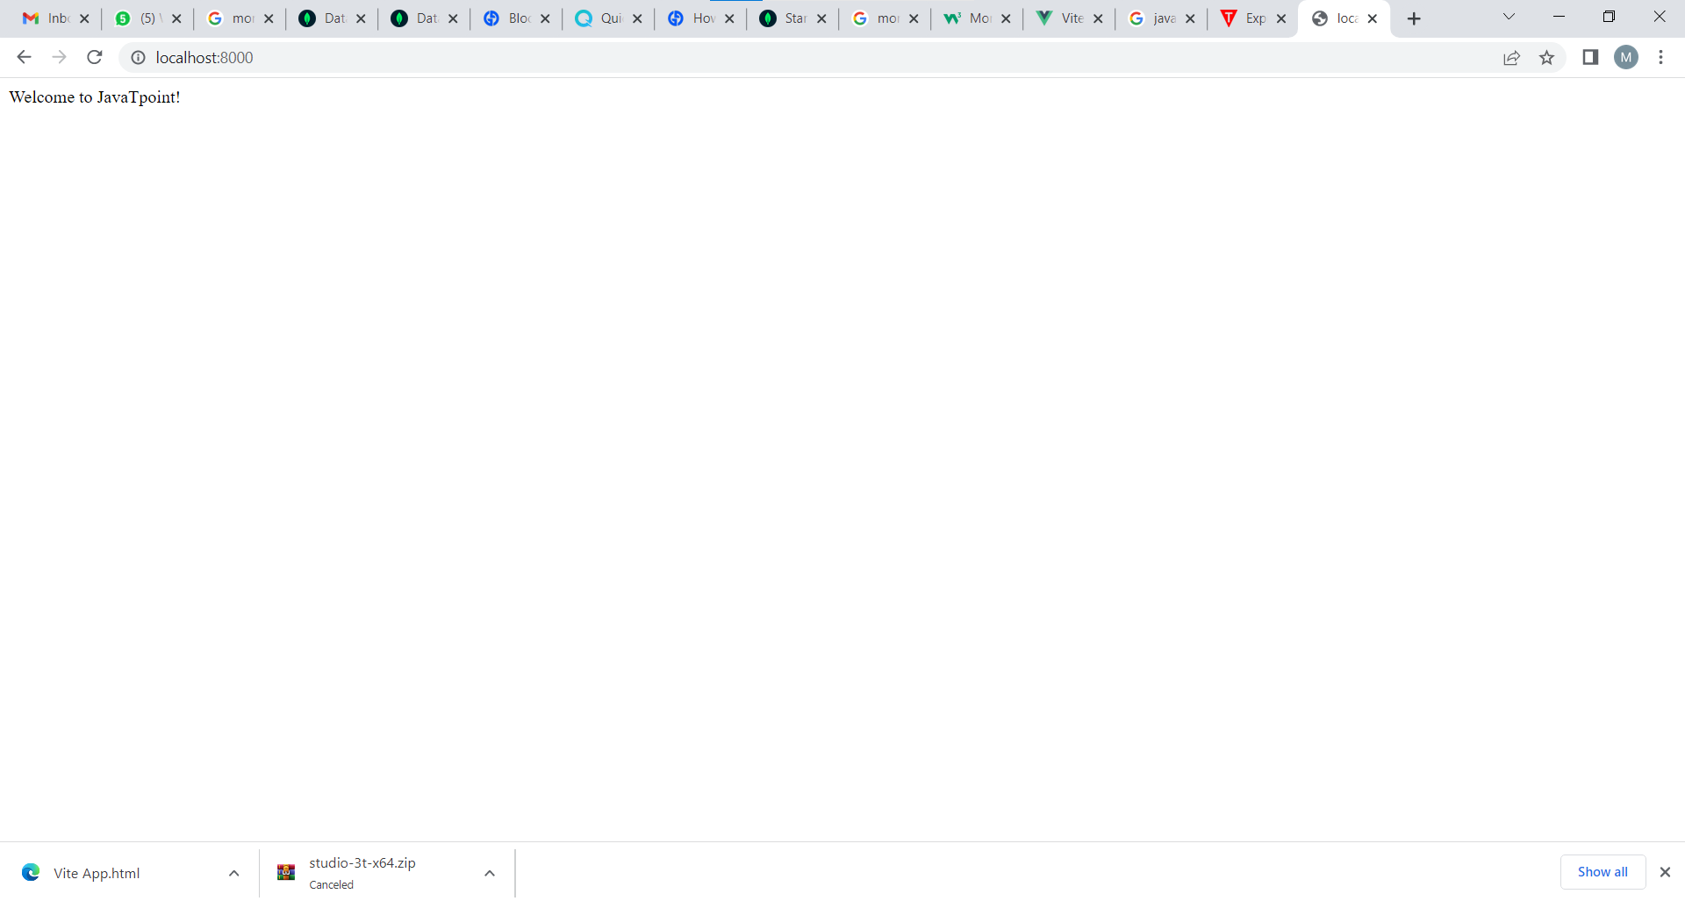

**Express.js get:**

**Index.html**

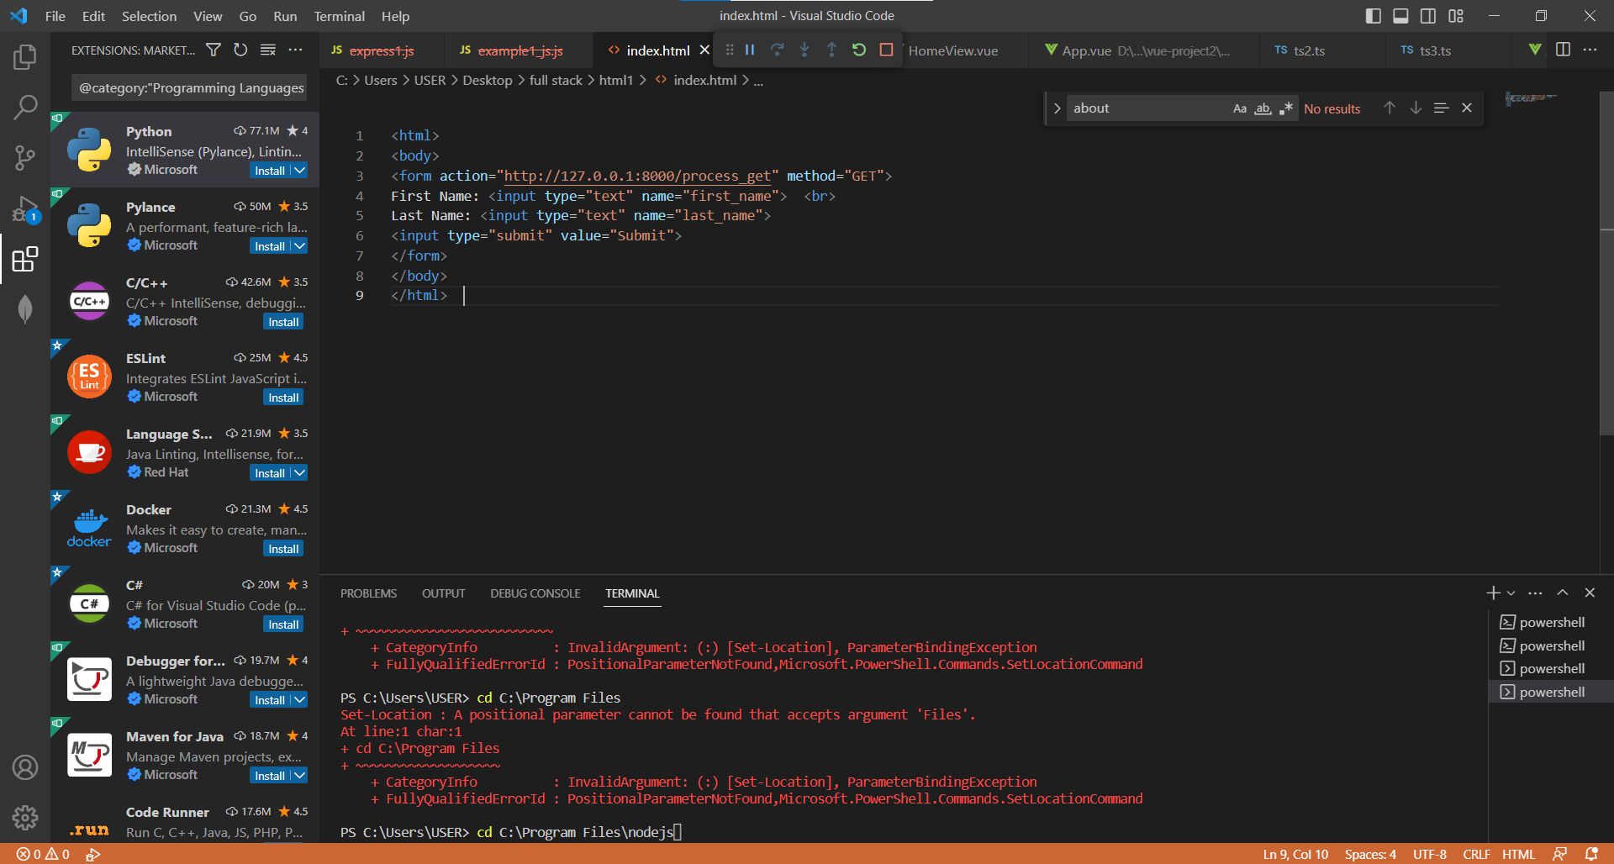

**Example1_js.js:**

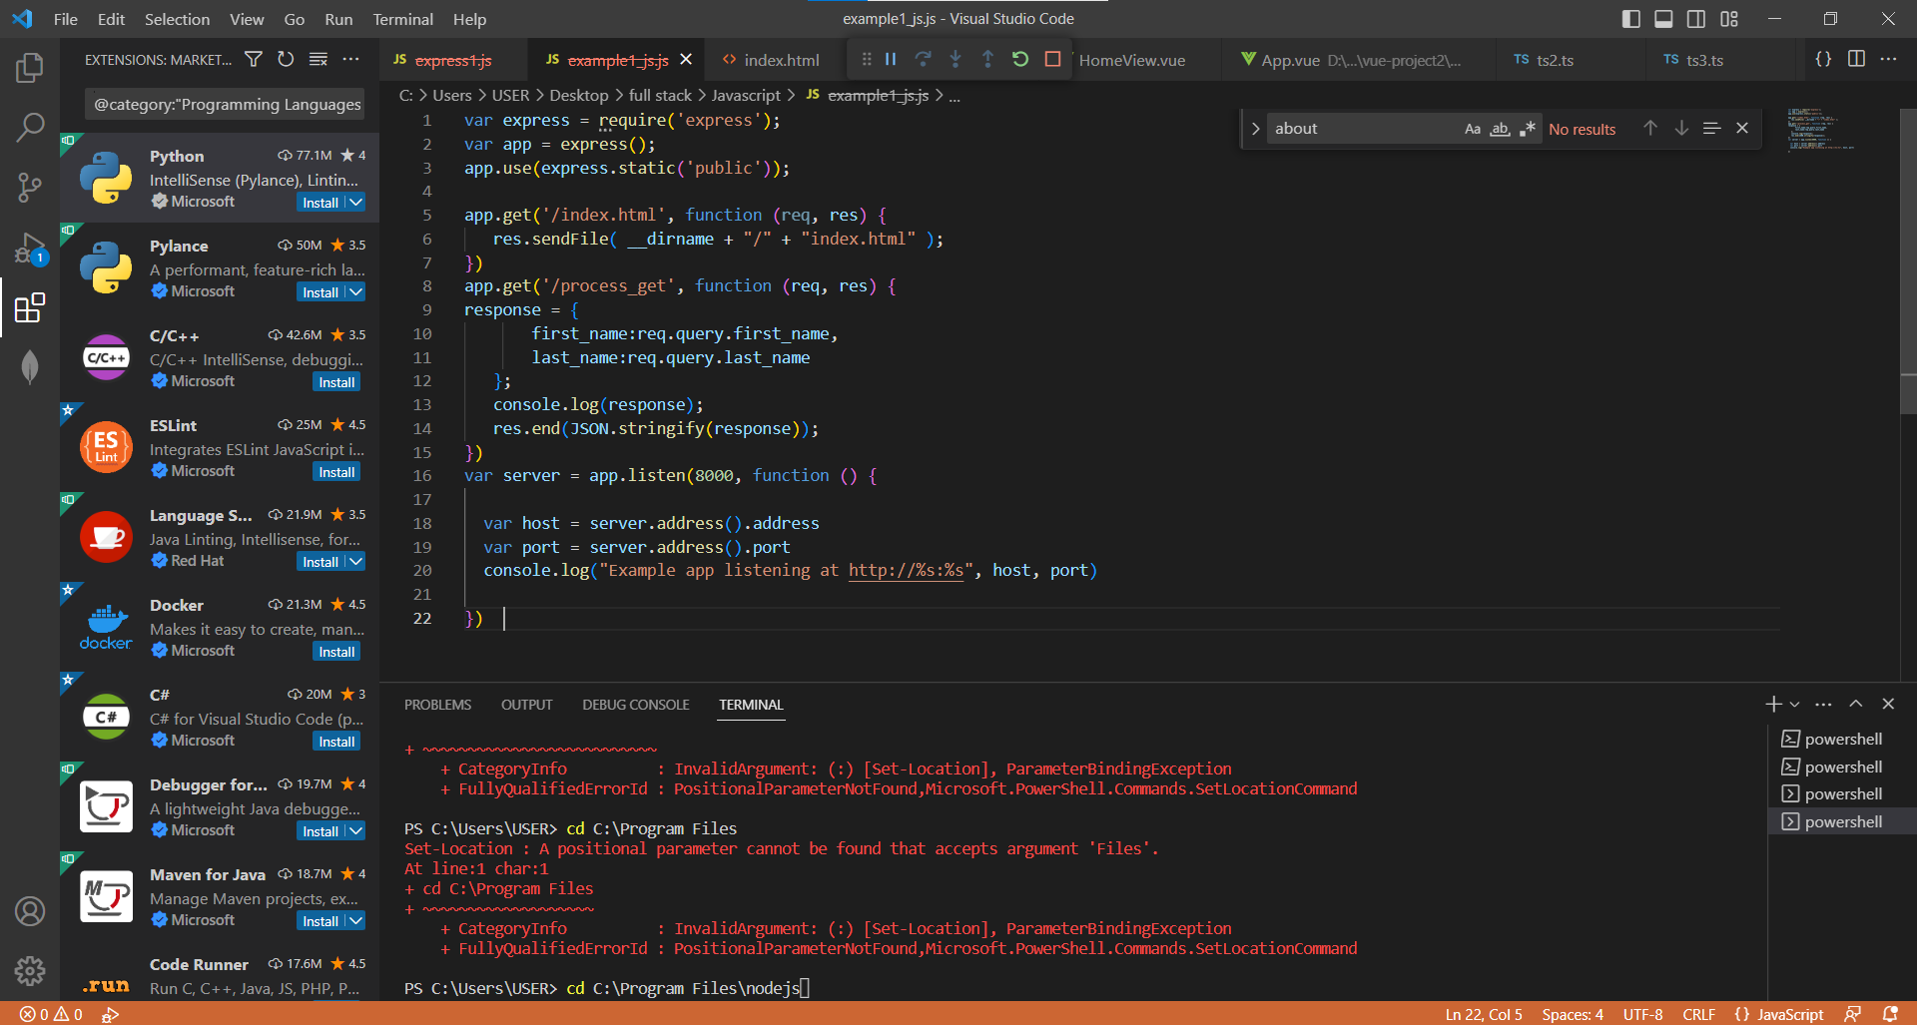

**First run the HTML file and then feed the input in html browser page..automatically got the output in command prompt page.**

**o/p**

